INDIVIDUAL MEMBERSHIP FORM

Date Filled:_______________

500 php – ASTR annual membership, certificate, and official receipt
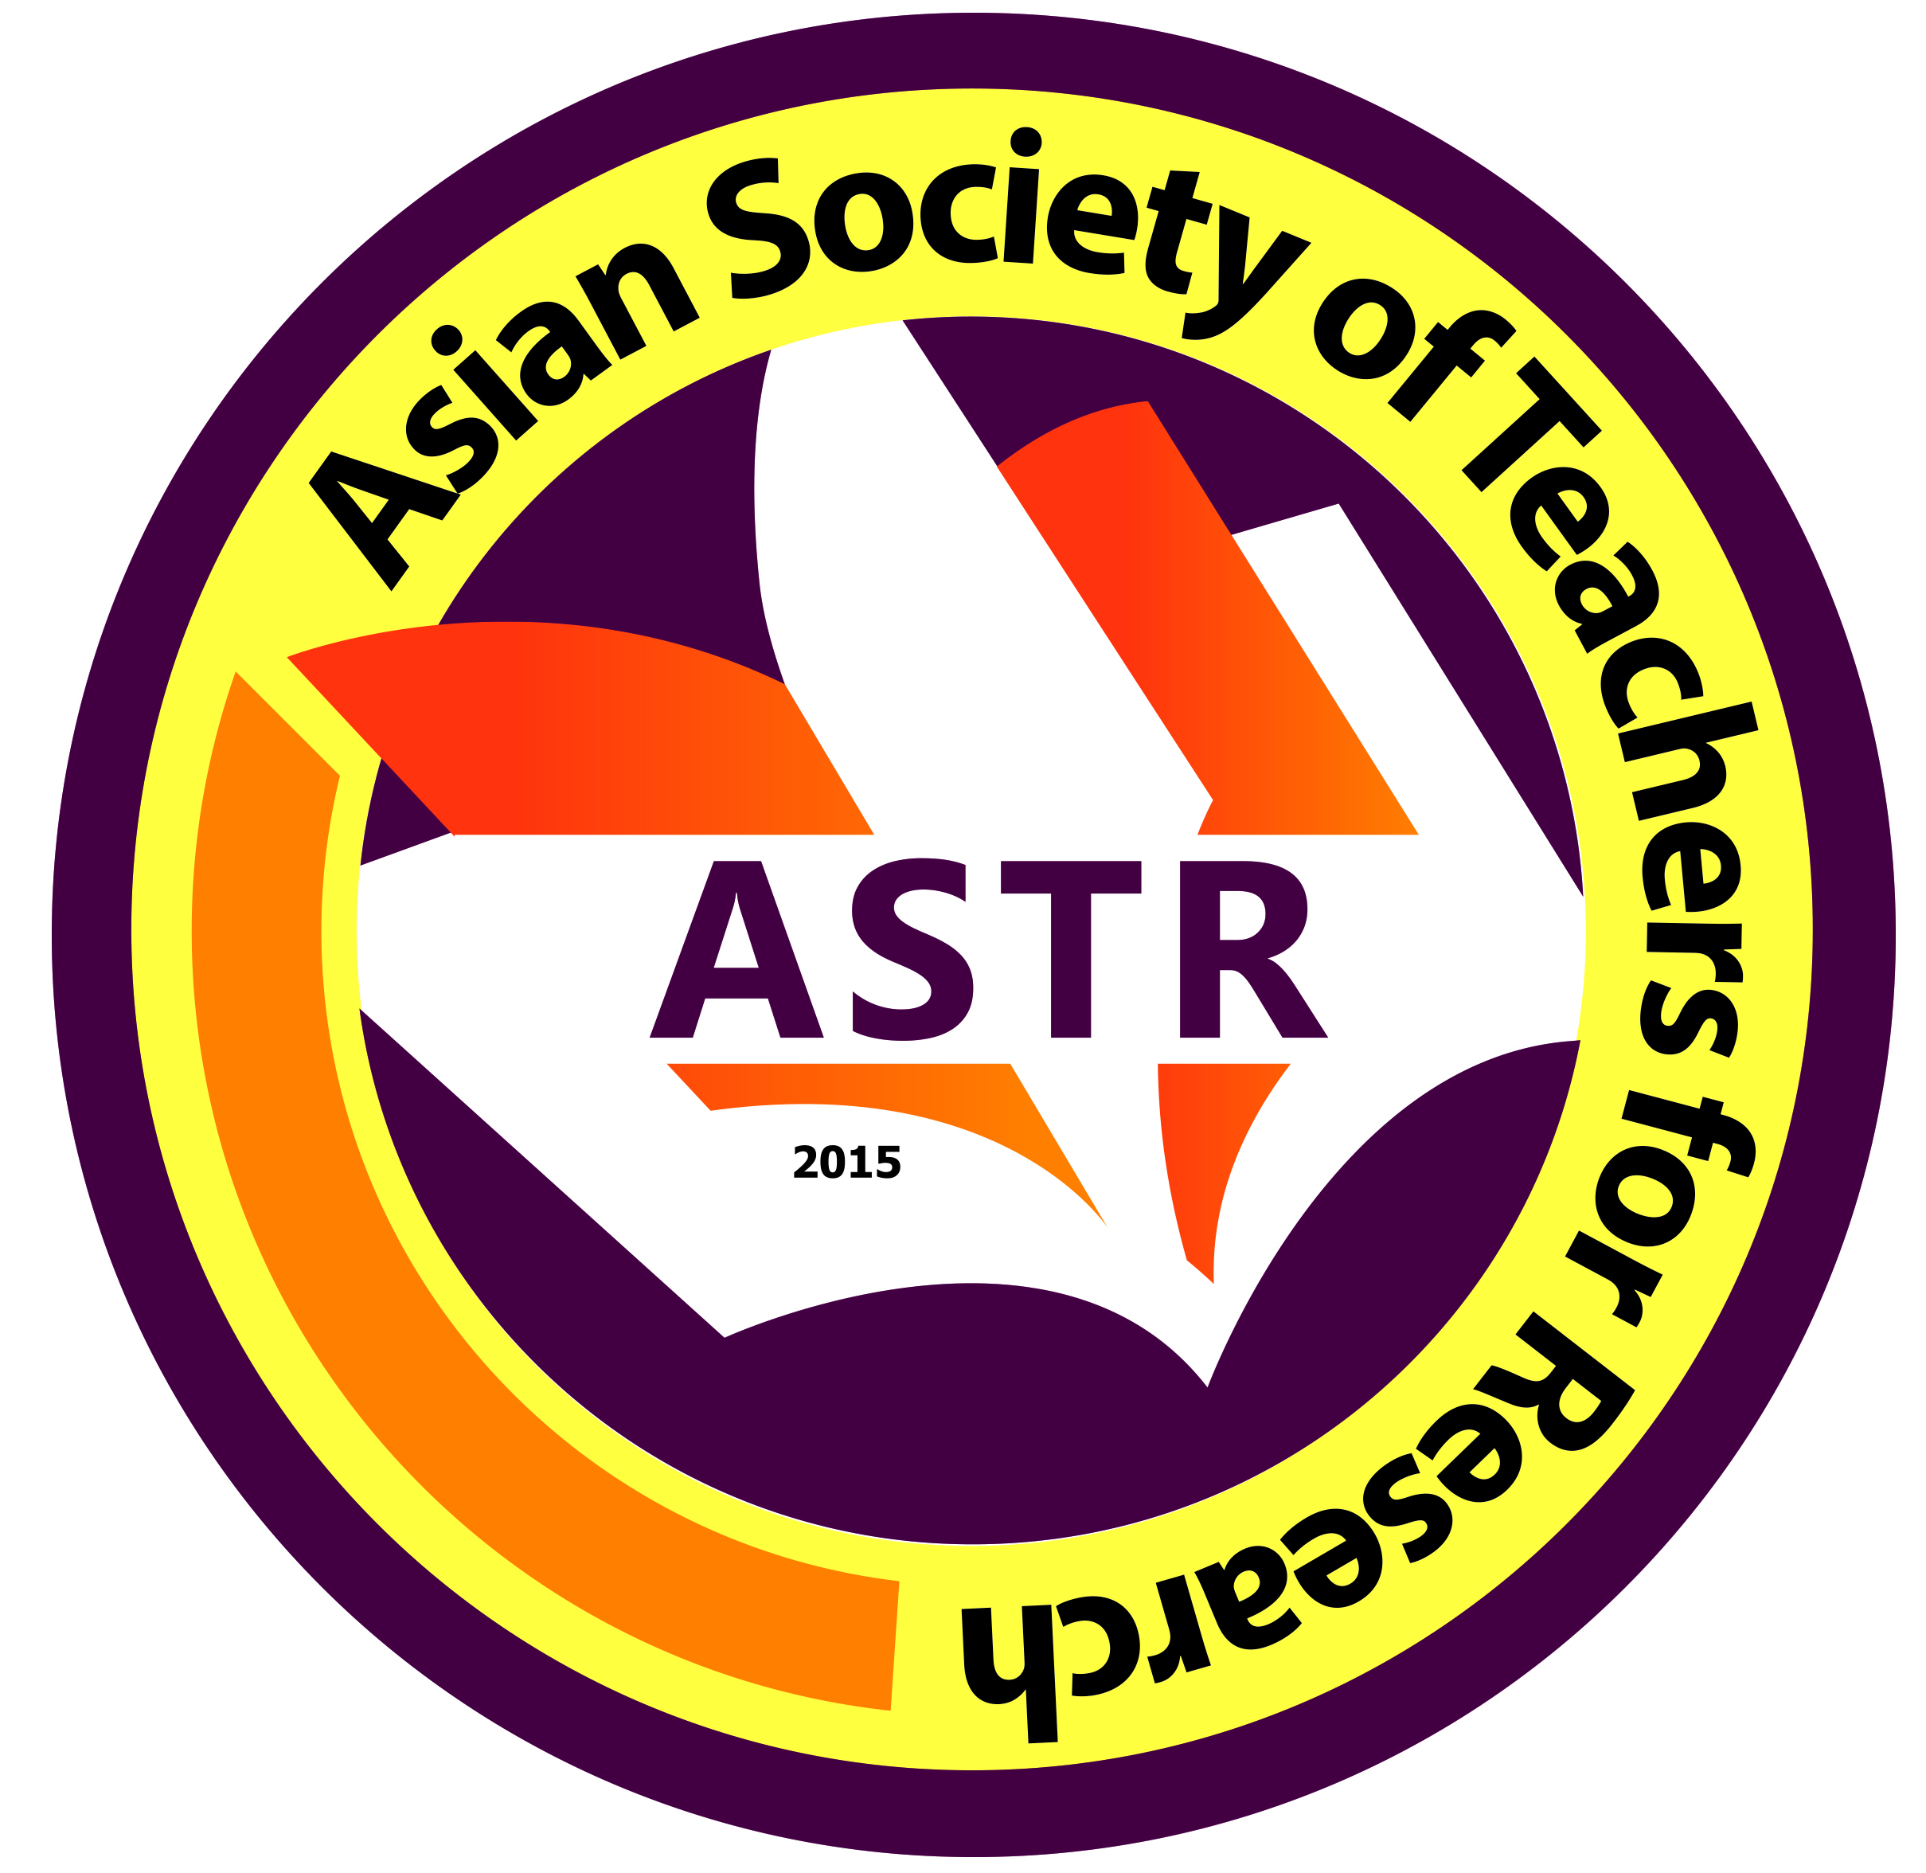
700 php – ASTR annual membership, certificate, PvC ID and official receipt

*COURIER FEE 180 php

PERSONAL INFORMATION

Name: ______________________________________ Email: _______________________________________
Facebook Name: _____________________________________________________________________________
Contact No: __________________________________ Date of Birth: ______________________________
Address: ______________________________________________________________________________________
Organization/School/University: _________________________________________________________
Highest Educational Background: ___________________________________________________
Vice President for Research/Research Director: _________________________________________
Contact No: ___________________________________________
Email Address: __________________________________________

Please fill-out the form, scan, and send to astr@aseanresearch.org. You may also personally return the filled-out form to any personnel of ASTR, Inc.

ASTR BANK ACCOUNT
Name of Bank: Bank of the Philippine Islands
Address: Georgetown Cybermall, Cagayan de Oro City, Philippines
Account Name: Asian Society of Teachers for Research Inc
Account Number: 8991-0004-62 (PESO SAVINGS ACCOUNT)

About ASTR, Inc.
The Asian Society of Teachers for Research Inc. is an organization devoted to the advancement of pedagogy/andragogy in the teaching of research in all academic levels. Established in 2015, it has over 2100 members * from the Philippines and all over Asia.

